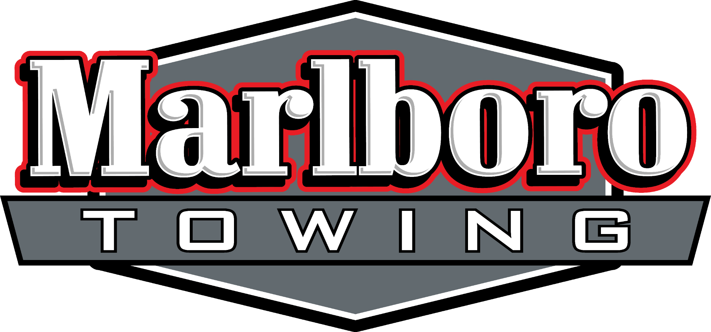

Annual Background Screening

Full Name: ___________________________________________
SS# : _______________________
D.O.B.: _______________________
DL#: _______________________
Current Address:
___________________________________________________________________

I _______________________________________ Hereby Authorize Marlboro Towing LLC to use my personal information to obtain a background screening through HIRE RIGHT companies for the purpose of verifying my eligibility to run calls for AAA Roadside Services.

Signature: ______________________________
Date: ______________________________

